J. Soc. Cosmet. Chem. Jpn. 54(1): 00-00
Original, Short Communication, Material or Review ―――――――――――――

How to Write an Original Paper Using This Template
Ichiro Yamada^{1＊}, Jiro Suzuki¹, John Smith²
¹ Research and Development Department, SCCJ Corporation, 1-2-3, ○○, Minato-ku, Tokyo 000-0000, JAPAN
² ABC Department, IFSCC University, 123 Wall Street, New York, NY 00000, USA

From here, please write the abstract in 200‒300 words (Times New Roman, 10-point size). The above article title is set at 16-point (Times New Roman, bold). Use 12-point (Times New Roman) for author's name, and 11-point (Times New Roman) for affiliation and address.
Please add * in superscript on the name of the corresponding author, and enter his/her email address at the bottom of this page.

(leave one line space)
Key words: Enter 10 or more important key words extracted from the title and the abstract, and arrange the key words in the order of importance.

1. Introduction

Please write the text (Introduction) from here. Please use 10.5-point Times New Roman font. However, please use 11-point bold font for headings and subheadings.
For details on how to write the manuscript, please refer to the "Journal of the Society of Cosmetic Chemists of Japan Manuscript Submission Guideline".

――――――――――――――――――――――――――――――――――――――――――――――
Received, January 0, 2020; Accepted March 0, 2020
* Corresponding author: Please enter the email address here.

doi.org/10.5107/sccj.
© 2020 The Society of Cosmetic Chemists of Japan

(leave one line space)
2. Materials and Methods

From here, please write the materials and methods.

2.1. Insertion of figures and tables (capitalize the first word of a sentence)
Please paste or prepare the figure and table in the upper or lower portion of the appropriate page. For the caption of a figure, write "Fig.- 0" below the figure, and for a table, write "Table-0" above the table. Then, write the title and description after the numbering. If publication in grayscale is desired, please paste a black-and-white diagram or photograph. If the option of color figure is chosen, please paste a color diagram or photograph.
*Please attach the original figure(s) and table(s) after the text in enlarged version (clear version).

2.2. Preparation of table
To prepare a table directly in the manuscript, please use 10.5-point Times New Roman font.

2.3. Insertion of formula
Please refer to the "Manuscript Submission Guidelines".

(leave one line space)
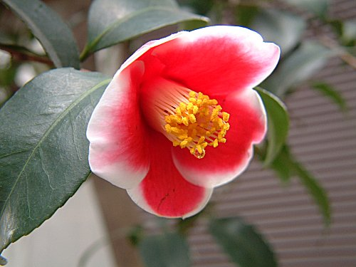
Table-1 Results of the number and type.
――――――――――――――――――――――
Number Type
――――――――――――――――――――――
5 A
7 C
3 B
11 B
8 A
――――――――――――――――――――――
A: white, B: red, C: pink.

Fig.-1 Japanese camellia.
The name of this Japanese camellia is ‘Tamanoura’.
(leave one line space)

(leave one line space)
3. Results

From here, please write the results.

(leave one line space)
4. Discussion

From here, please write the discussions.

(leave one line space)
5. Conclusion

From here, please write the conclusion.

(leave one line space)
References

- M. Higuchi, K. Kitahara, K. Shimizu, K. Hirai, T. Matsumoto, M. Takahashi, J. Soc. Cosmet. Chem. Jpn., 50, 321-328 (2016) (Please list all authors.)
- J.P. Ebanks, A. Koshoffer, R.R. Wickett, S. Schwemberger, G. Babcock, T. Hakozaki, R.E. Boissy, J. Invest. Dermatol., 131, 1226-1233 (2011）
- M. Liebsch, D. Traue, C. Barrabas, H. Spielmann, F. Gerberik, L. Cruse, W. Diembeck, U. Pfannenbecker, J. Spieker, H. G. Holzhütter, P. Brantom, P. Aspin, J. Southee, Prevalidation of the EpiDerm Phototoxicity Test, ed. by D. Clark, S. Lisansky, R. Macmillan, CPL Press, Newbury, 1999, p.160-166
- S. Ota, T. Niimura, R. Azuma, R. Suzuki, K. Kameyama, Proceedings of the 75th SCCJ Research Symposium, 2014, p.8-9
- ISO 25178-2：2012
- U.S.P. 2,345,645 (1990)
- Koyama-kyugu, Kyudo Column. http://www.koyama-kyugu.com/archive/c017.php (accessed 2016.7.25)
- EYJAFJALLAJÖKULL VOLCANO ASH (160 GR.). http://nammi.is/islandische-vulkanasche-aus-dem-eyjafjallajokull-160-gr.html (accessed 2017.4.3)

Attachment
Fig.-1 Japanese camellia.
The name of this Japanese camellia is ‘Tamanoura’.

Table-1 Results of the number and type.
A: white, B: red, C: pink.
Revised in January 2020

